CSA-0619-Design and Analysis of Algorithm
CO4-AT1
Aim:
To develop a Dynamic Programming algorithm to find the number of unique paths from the top-left corner to the bottom-right corner of a grid containing obstacles, where the robot can move only right or down.
Algorithm:
- Start the program.
- Read the number of rows and columns.
- Read the obstacle grid.
- Create a DP table of size rows × columns and initialize all values to 0.
- Check whether the starting cell contains an obstacle.
  - If yes, the number of paths is 0.
  - Otherwise, set dp[0][0] = 1.
- Initialize the first column:
  - If there is no obstacle, copy the path value from the cell above.
- Initialize the first row:
  - If there is no obstacle, copy the path value from the previous cell.
- For every remaining cell:
  - If the cell contains an obstacle, set its path count to 0.
  - Otherwise, calculate:
dp[i][j] = dp[i-1] [j] + dp[i][j-1]
- The value in the bottom-right cell represents the total number of valid paths.
- Display the result.
- Stop.

Implementation:
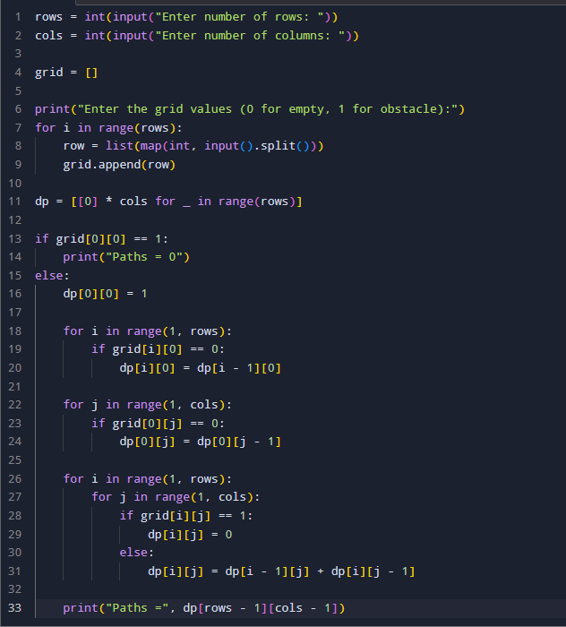
Output:
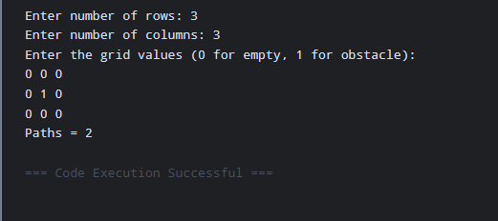

Time Complexity: O(m×n)
Space Complexity: O (m × n)

Report Analysis
The Unique Paths with Obstacles problem was solved using the Dynamic Programming approach. Each cell in the DP table stores the number of possible ways to reach that particular cell. Since the robot can move only to the right or down, the number of paths to a non-obstacle cell is calculated by adding the paths from the cell above and the cell to the left. If a cell contains an obstacle, its path count is set to zero because the robot cannot move through it.
For the given sample grid, the obstacle in the middle blocks some possible paths. After calculating all valid movements using Dynamic Programming, the total number of paths from the starting position to the destination is 2. The approach is efficient because it avoids recalculating the same paths multiple times and solves the problem in O(m × n) time.

